Student’s name | …………………………………………………….…… | Grade | 3
Subject | Computer | Week No. | 8
Lesson Title | Loops | Unit
Worksheet No. ( 8 ) (Answer)

write the correct name of each part.

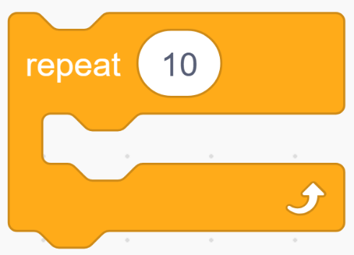
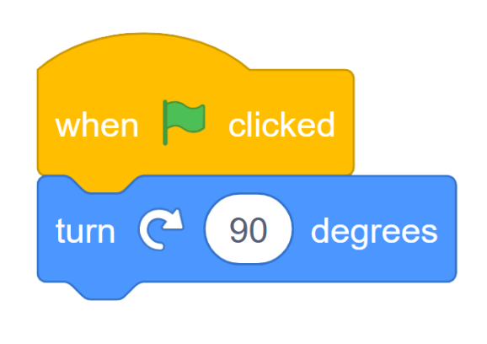

Default sprite
repeat
Code
CD Rom
repeat
CD Rom
Code
RAM
Default sprite
Good Luck

